**Multimedia Databases Final Exam May 2020**

**Student Name:** Mark Carley

**Student Number:** 20071864

**Module:** Multimedia Databases

**Course:** Creative Computing

**Q1.** **(A)**

1. Abstraction is the steps taken to identify different aspects of an entity while ignoring any non-important properties. Encapsulation is where an object contains both the data structure and all the operations to manipulate it.
2. An object is unique identifier which has both attributes to describe the current state of a real-world object and all actions regarding it. Attributes contain the current state of an object, these attributes can be either simple or complex. A simple attribute can be something like a string or integer containing literal values. A complex value may contain different collections and/or referencing between objects.
3. An Object Identity (OID) is attached to an object when it created by the following factors: Are generated by the system, has a unique identifier assigned to the object, invariant meaning it can’t be altered during its lifetime and not visible to the user.
4. Methods are used to define the different behaviour of an object with a set of enclosed functions. A message is a request from one object to another where it asks the second object to execute one of its methods.
5. A class is like a blueprint for describing a set of objects that are similar to one another. All the objects that are stored in a class are called instances. A class has its own attributes and methods in relation to that class.

A subclass is an individual class that is extracted from a superclass. Unlike a class, a subclass inherits all the properties of a superclass but contains its own attributes.

A superclass is something that can be made from many subclasses. Any subclasses contain all the characteristics of the superclass. A superclass also has what is known as a parent class.

1. Inheritance allows you to share attributes between different objects in a way that a subclass would have access to attributes from the parent class. The four types of inheritance are single, multiple, repeated and selective.

**(B)**

Ontologies are used as representations to describe different entities such as vehicles, people or tables. Ontologies are growing more important for different applications as there being used to develop different kinds of multimedia data such as video, text, image and audio objects.

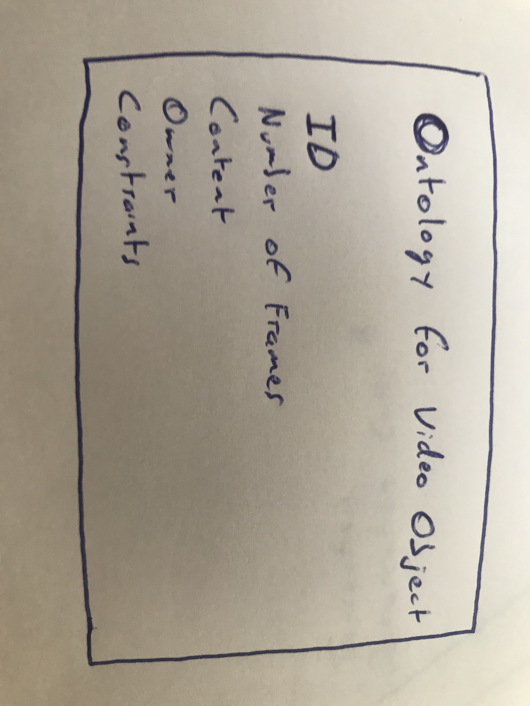

**(C)**

(i) The approach to Loose coupling is that any multimedia data is handled by the file system while all the metadata is handles by the database system. The advantage to using Loose coupling is that you can use multiple file systems to manage multimedia data.

The idea of Tight coupling is being able to manage multimedia data and metadata by the database system itself. The advantage to Tight coupling is that functions can be applied to the multimedia database.

(ii) A schema is metadata that’s able to outline information from multimedia data. Three schema architecture can be applied to a multimedia database system. The external schema defines views in a database, the internal schema makes use of the physical data model and the conceptual schema describes the structure of the database.

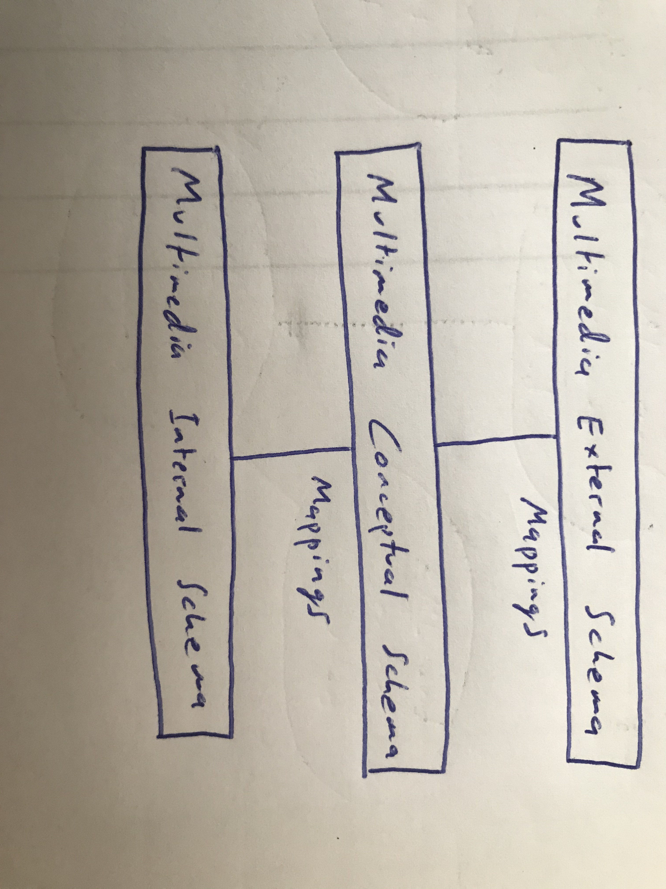

(iii) A functional architecture lays out the functions included in a multimedia database system such as distribution, query/update processing, data representation, browsing and editing, metadata management, storage management and security management. Below is an example that shows the functional architecture and shows each individual layer.

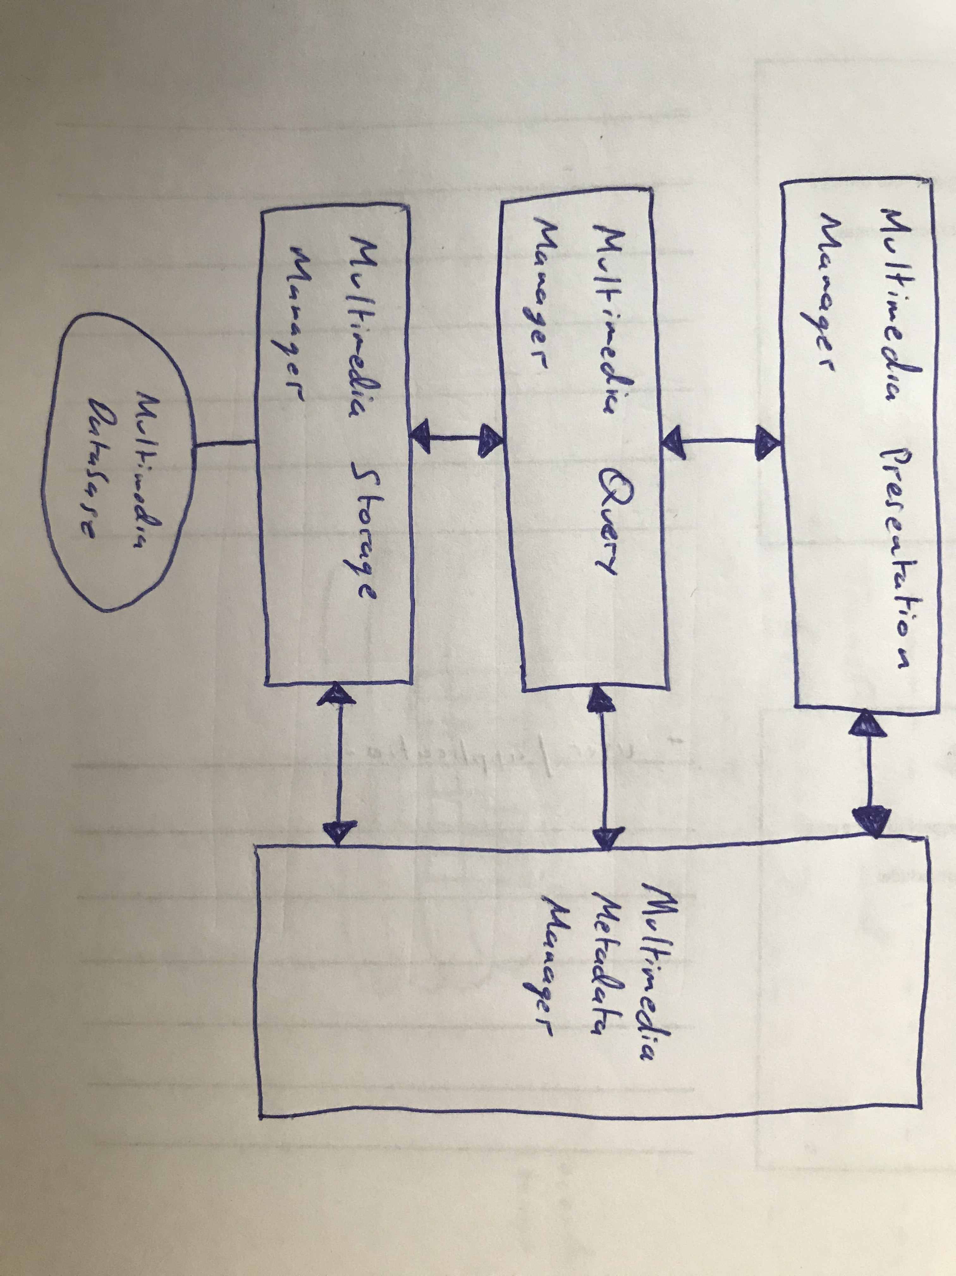

The presentation layer shows all the media types back to the user. The query manager is in charge of query processing, storage manager accesses the multimedia database and the metadata manager organizes all the metadata.

(iv) Multimedia database systems can also make use of an object-orientated database management system to organize and manage multimedia objects. Extensions may also be put in use to provide support to multimedia data between objects.

(v) What is meant by distribution is a collection of Multimedia Database Management Systems connected to a network. Below I’ve is diagram showcasing distributed architecture, the modules in the diagram called distribution processor is in charge of handling data distribution issues, metadata, transactions, metadata and security/integrity management.

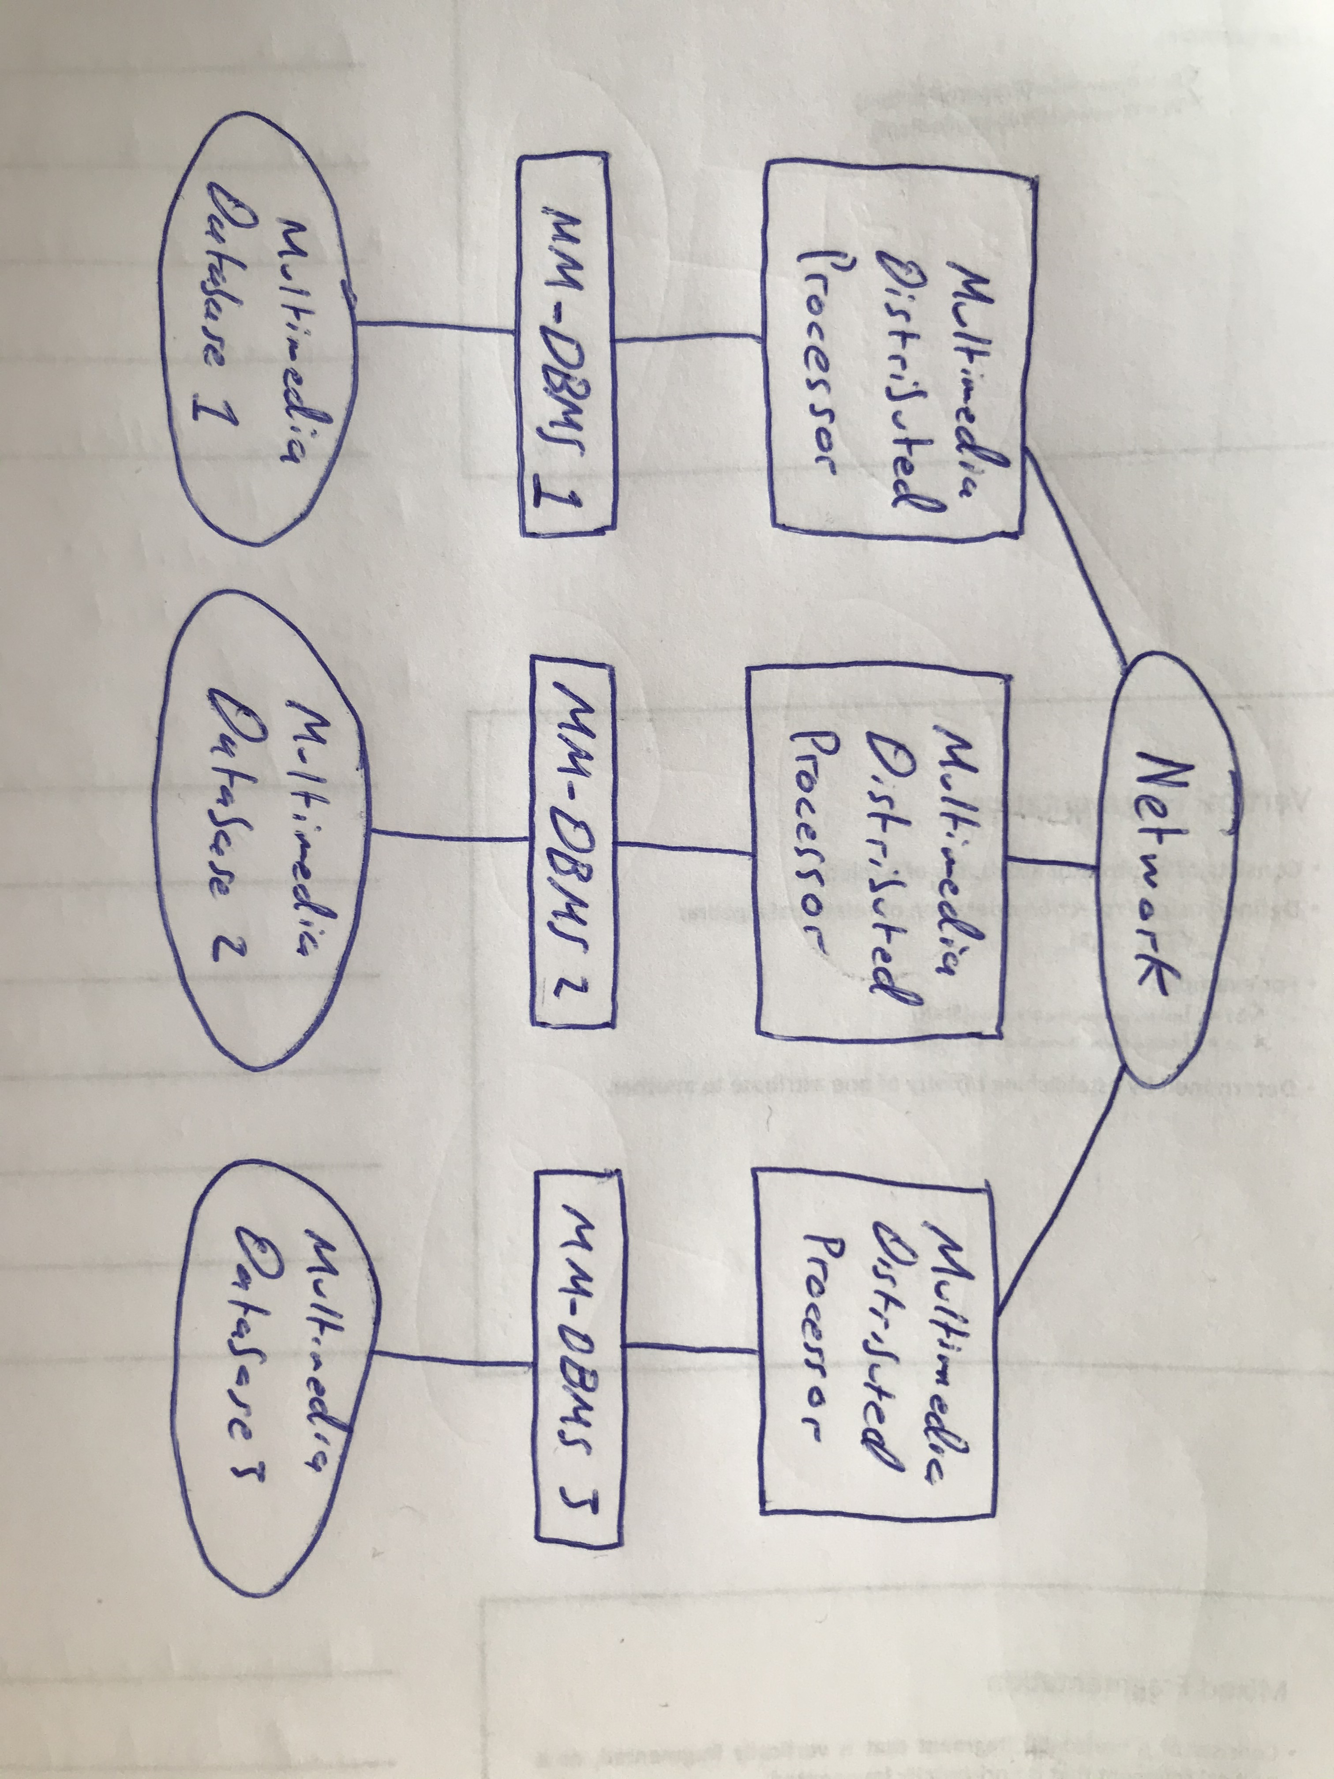

(vii)

**(D)**

(i) Access methods are a form of method used to access data and process different queries. Any access methods that try to access the database depend on the indexing methods,

(ii)

(iii) The single disk storage method is where all multimedia data is stored on one disk. A multimedia database can have text, images, videos and audio data, the data can be either saved continuously or scattered randomly.

(iv) Another method which is called multiple disk storage, is where objects are spread across multiple disks. For example text stored on disk 1, image on disk 2, video on disk 3 and audio on disk 4. Another type of method for multiple disk storage would be distributing text and video on one disk while having image and audio stored on another disk.

(v) Disk striping is where multimedia objects are stored on more than one disk (objects spread across multiple disks). This helps divide large amounts of data blocks and spread them across different storage devices, disk striping can help benefit larger databases. An example in which a storage system can incorporate disk striping is to stripe a 32 kilobyte block on the first, second and third disk and start over at the first again.

**(E)**

(i) There are different retrieval methods for getting back colour, the first is finding the Hue (Colour pixel), Saturation (colour depth) and Intensity (brightness). The use of colour histogram can be used for generating and storing each image in a database. A user can query back colours by colour code (#fffff) or by the proportions of a colour as well (65% blue).

(ii) This method can fetch texture values back by using different pixel intensity values which can come from reflection of light. The images can be retrieved in one of two ways, by suppling a sample query image or selecting texture values from a palette.

(iii) In order to retrieve a shape, the shape has to be given a quantitative description which can match other images when looking for it. This method revolves around recording different characteristics on a objects shape which are independent of both the orientation/size. From here all the characteristics are scanned through all objects that are associated with each image that’s stored. Queries fetched back to the user are done by matching the same features of the shape that match the image.

(iv) This method uses what’s called spatial location which searched through image collections in a database that contain objects who are described to have a spatial relationship with each other.

(v) Many types of features regarding images have been used as a basis for content-based image retrieval. Some images undergo different transformations such as pixel intensity which don’t reflect the description of that image. The techniques used are similar to how a human see’s an image and focuses on extracting those features from an image.

(vi) Retrieving an object based on appearance alone can be difficult and completely depends on the viewpoint and shape of the image. It’s done by measuring the orientation and curvature of an image.

**Q3.**

**(A)**

(i) In (**2PC**) there are two main phases, the voting phase and the decision phase. All participants are assigned a co-ordinator and are asked to commit a transaction. When making a vote, if one participant fails to vote or votes no then the co-ordinator instructs all other participants to abort the transaction. If everybody votes yes then the co-ordinator shows all participants to vote yes. If one participant votes to abort a transaction then it’s free to abort the transaction straight away and in the case of a participant votes commit they still wait for the co-ordinator to broadcast out a global-commit but if a participant failed to vote then a automatic abort is assumed.

Another non-blocking protocol is three-phased commit protocol (**3PC**) which implements non-blocking in case of site failures but with the exception of an event of failure on every site. If there is communication failures between sites then that can break atomicity between global transactions, 3PC also removes the waiting period for participants awaiting a global transaction and have already voted. 3PC has a third stage called pre-commit which is set between voting and global decision. When the co-ordinator receives all votes then a global pre-commit message is sent and when participants receive that pre-commit message they know all other participants have voted for sure.

(ii) **2PC** termination protocols are only invoked if either a participant or co-ordinator do not receive an expected message and therefore times out. If a timeout occurs in WAITING state under a co-ordinator then a globally aborted transaction goes forward and if a timeout happens in a DECIDED state then the co-ordinator sends the global decision again to sites that haven’t acknowledges back. When discussing termination protocols in relation to the participant, the easiest protocol is to block the participant until a communication link is established with the co-ordinator. In relation to a participant when a timeout happens in a INITIAL state then a group abort transaction occurs. If a timeout happens under a PREPARED state then without further information, the participant is automatically blocked and a decision could be made from a different participant.

For **3PC** under termination protocols, if a co-ordinator is in timeout in a WAITING state then it’s identical to 2PC where a global abort transaction is engaged. If a timeout happens in a PRE-COMMITTED state then a write commit record is logged and sent as a GLOBAL-COMMIT message. And finally if there’s a timeout in a DECIDED state then yet again it’s the same as 2PC where a global decision is sent to sites who haven’t acknowledged the first decision sent. When discussing termination protocols in relation to a participant for 3PC if a timeout occurs in a INITIAL state then similar to 2PC, a group abort transaction happens. Timeouts that happen in a PREPARED state are followed by an election protocol for the election of a new co-ordinator. Lastly if a timeout occurs under a PRE-COMMITED state then it’s identical to a PREPARED state where a new co-ordinator is picked.

(iii) When talking about (**2PC**) recovery protocols in case a failure event happens if under a co-ordinator failure, a co-ordinator has three failure states. If a failure occurs in an INITIAL state then the recovery protocol starts a new commit procedure. In a WAITING state the recovery protocol restarts a commit procedure. And finally when a failure happens in a DECIDED state when restarted, if all acknowledgments are made to a co-ordinator then it’s completed, if not then the termination protocols mentioned earlier are put in place.

In relation to recovery protocols (**3PC**), if a co-ordinator failure happens there are four states of failure:

* In case of a failure in an INITIAL state then the recovery protocol begins a new commit.
* In the event of a WAITING state then other sites are contacted in regards the fate of a transaction.
* A failure in a PRE-COMMITTED is where other sites are contacted to see what happens to the transaction.
* If a failure happens in a DECIDED state, if all participants send in their acknowledgements then that completes a transaction if not then a termination protocol is processed.

Regarding recovery protocols (**3PC**) for a participant failure there are four individual states of failure:

* If in an INITIAL state of failure then a universal group abort transaction is put through.
* A failure in terms of a PREPARED state will have all sites contacted to determine the fate of a transaction.
* In a PRE-COMMITED state, similar circumstances occur where all sites are other sites are contacted to decide what to do with the transaction.
* If a failure occurs under a ABORTED/COMMITED state then once restarted, no other actions are necessary.

**(B)**

(i) Metadata for text is information containing text for a book or newspaper while content-independent metadata contains information such as what type of text is being used and the total number of pages. Large volumes of text metadata can also be annotated for storing essential information.

(ii) Metadata for images can be one of two things, firstly it can include text data that describes an image or information containing properties of that image in a relational database. In relation to images they also can be described as annotations so that when you click on a image online it may show the annotations of that image.

(iii) Video metadata is continuous media and is handled similarly to audio metadata in that the different frames of a video clip are stored in the video database while the information contained in the frames is the metadata. Images can also be extracted from video clips and stored as metadata which can later be used for video retrieval.

(iv) Audio data is stored as speech data and text data which describes the different frames that are contained in the speech. For example frame 1000-2000 contains an introduction speech and frame 2000-3000 contains a conclusion. Audio data can also be tagged along with text which can be used to extract and analyze audio data from the text.

**(C)**

The three architectures are principle of autonomy, principle of uniformity and the principle of hybrid organization. In the principle of autonomy, if a user groups all images, videos, documents and index those objects “in a way that is maximally efficient for the expected types of accesses that are planned to be made on those objects”. This ensures all types of media are organized in a certain way.

For the principle of uniformity, it is trying to represent different kinds of media objects within one data structure and from there create algorithms to query the data structure. Lastly the principle of hybrid organization, is a combination of the previous two principles where only certain media types can use their own indexes while others use a unified index.

The main disadvantages of the principle of autonomy is that it requires algorithms as well as data structures for each media type, techniques are needed to calculate joins across different data structures but can prove complex and time consuming. The advantages to this however by creating these unique structures that can access each media type it speeds up query processing.

The main advantages to the principle of uniformity is it’s easier to implement and resulting algorithms are faster. The disadvantages to the principle is it requires the use of annotations either manual/auto. If the language isn’t expressive enough for annotations then some information can be lost.

For the principle of hybrid organization it takes the advantages of the previous two principles with fewer disadvantages.

**(D)**

(i) Object editing is a way of editing multimedia objects. The way of doing this would either by merging two objects together to form a third object or you can extend an object to form a smaller one. With object editing, objects can be joined together using intervals.

(ii) Browsing multimedia objects is done out by a hypermedia database management system. A diagram below shows browsing in action by presenting the use of nodes and links.

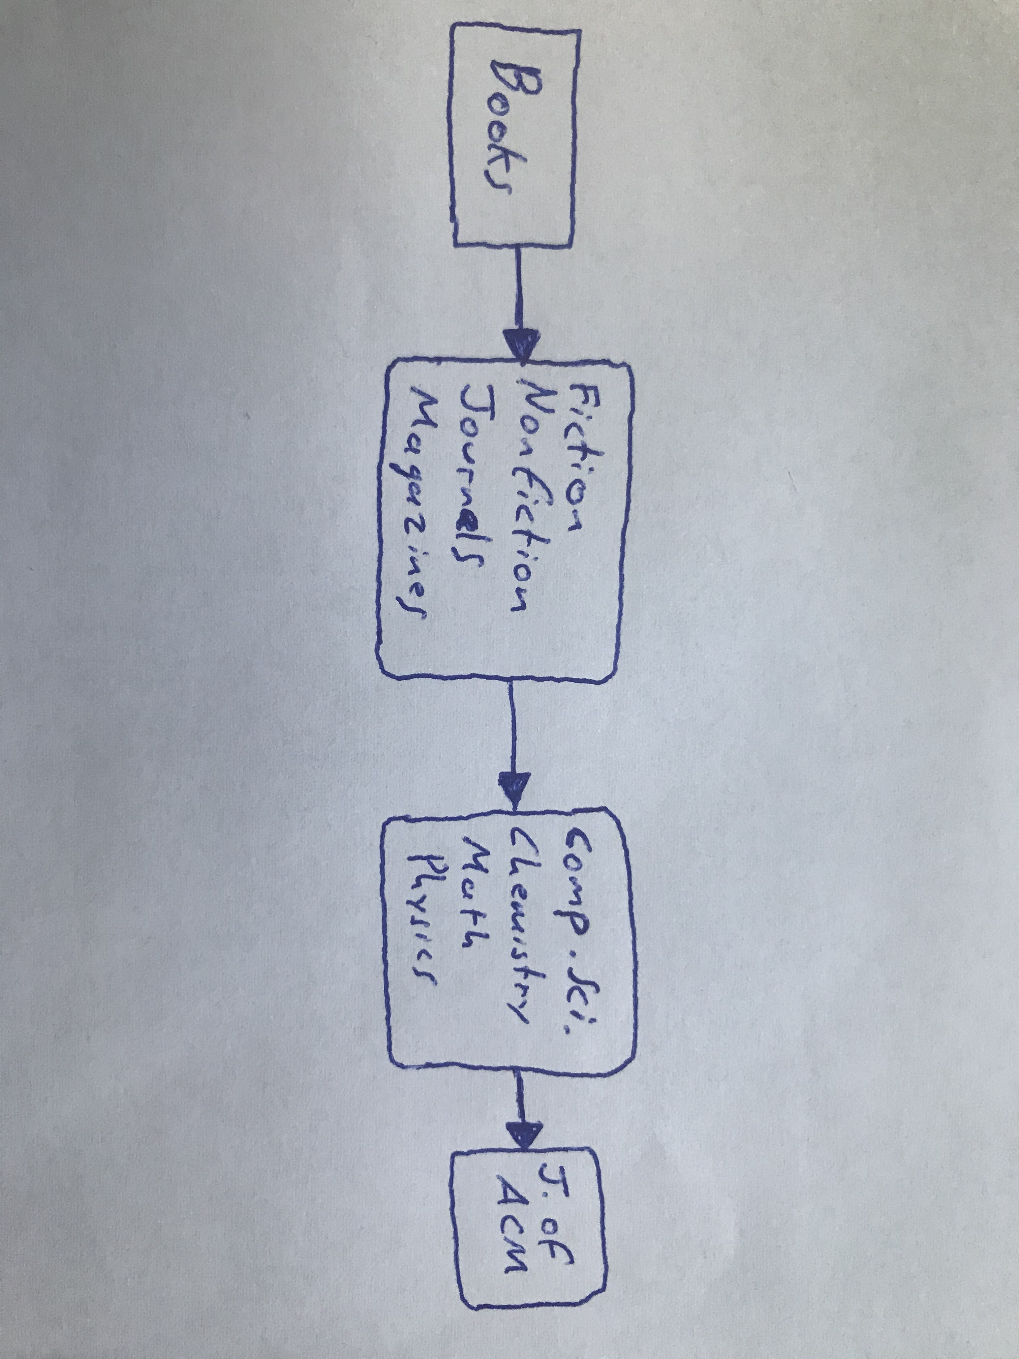

In the diagram you navigate by clicking the links to reach the nodes and get back the required multimedia data.

(iii) Filtering data is just removing any unwanted material, an example of this would be removing inappropriate language or footage from a video clip. This means before video clips can be shown to users they have to be filtered first.

(iv) Transaction management is a form of data manipulation as it requires querying and updating a database. An example of this is if a update has a image attached to it then it’s annotation has to be updated.

(v) Update processing is in conjunction to query processing/transaction management. It’s essentially just updating multimedia data that is related to a single user update. An example would be updating a book paragraph called paragraph A in a document called B and move it paragraph C instead.

(vi) Query processing is the way of translating complex queries into low-level expressions. There are different aspects needed for query processing, the first is a query language (SQL) and the second is different techniques for query processing. Any construct of a language used have to transformed into constructs that the system understands, that’s called query transformation. Query transformation is done in multiple steps, first a query shown on an external schema is transformed into a query for a conceptual schema, then it’s turned into a query on a physical schema.

Below is a diagram explaining what happens during query processing.

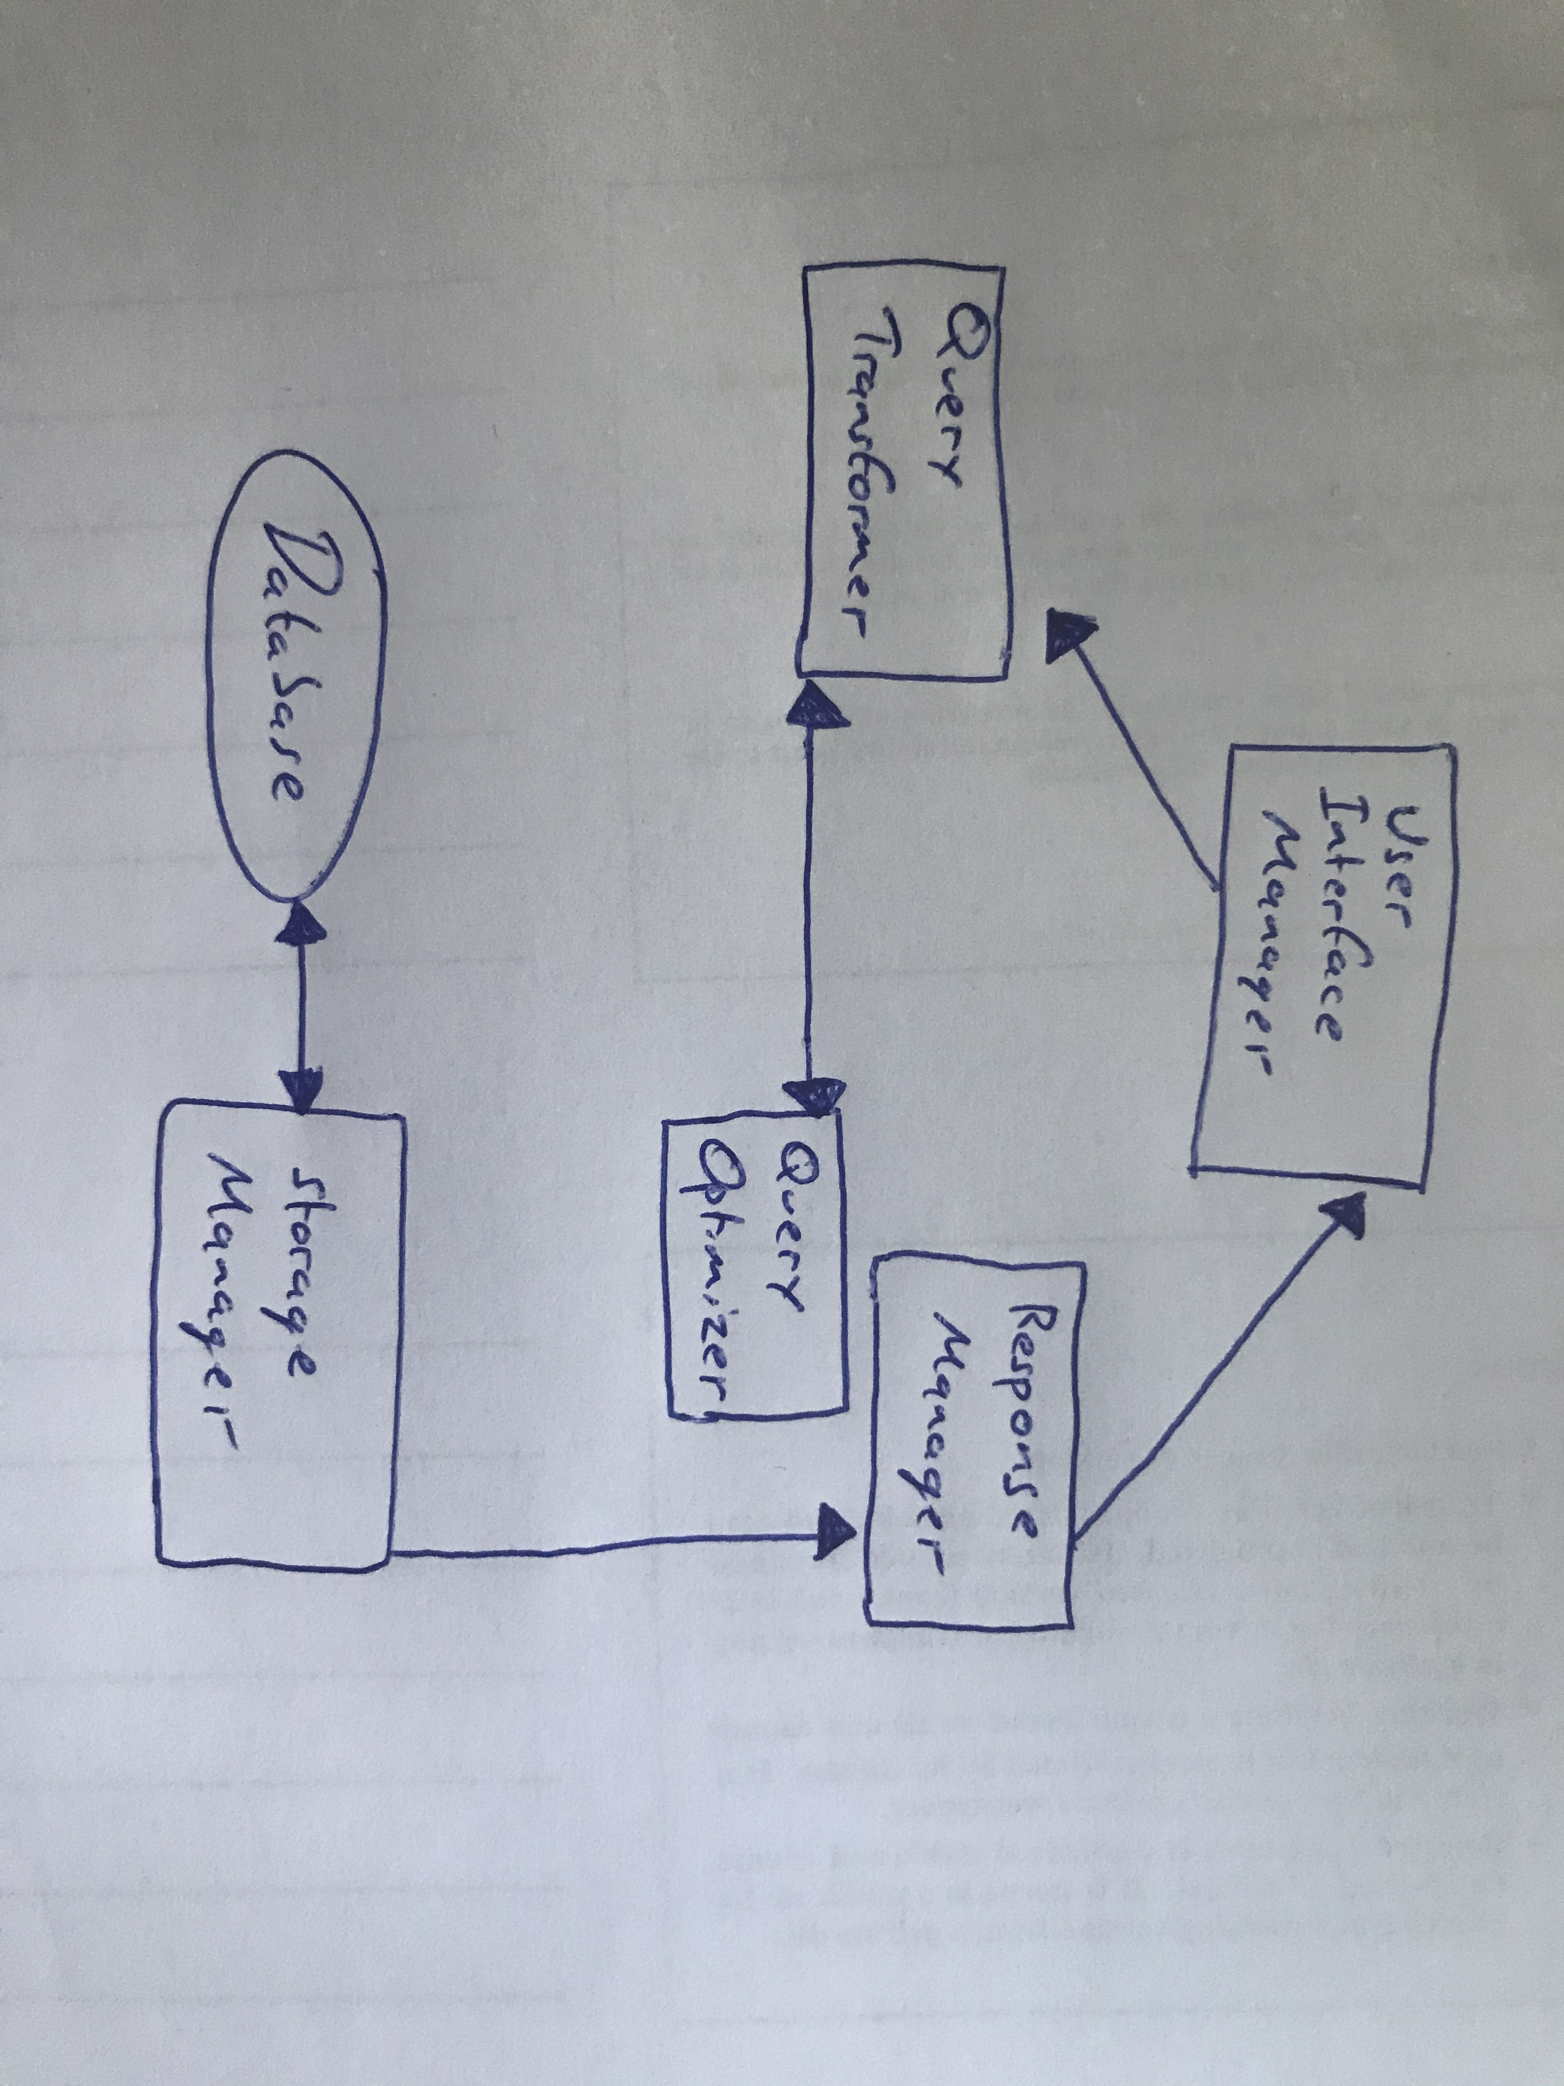

From this query processing diagram we see that the database is accessed through the storage manager, the response manager gives a response to the user. Both the query optimizer and query transformer communicate together to bring out execution strategies and the user interface manager accepts any queries, parses queries and returns them to the query transformer.

**(E)**

(i) Tr (Text Retrieval) is a way of processing information which returns a set of documents from a query. Only relevant documents to the query are shown to the user. The different kind of methods that can be achieved from this are proximity searching, inexact searching, use of intelligent searching (relevance, date, popularity) and matching words/phrases.

(ii) SDE (Schema-Directed Extraction) is a way of manipulating massive collections of related text objects. An SDE system can proceed through documents and extract the desired information, from there if fills in slots of the matching schema while only focusing on what matches the set criteria.

(iii) QDE (Query-Directed Extraction) is able to use queries related to a domain ontology by mapping different elements of that ontology to make organized text elements. It’s better used for documents relating to large businesses where documents have a specific layout pattern.

(vi) Precision is a way of measuring how well an engine can do in not giving back irrelevant document so if every document comes back at one hundred percent then it’s max precision. On the other hand the precision of a system is only factored by what information the system has access to.

(v) Recall is how well an engine can perform in locating relevant information through the documents and finding this information is only defined by if the information was extracted/retrieved from the system.